Case 13-US-Sioux-Pipe

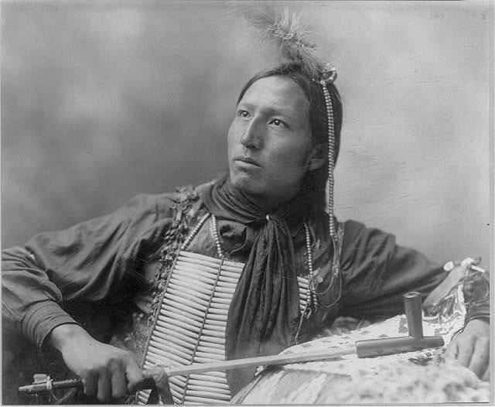

Title: John Comes Again [Sioux?]   
Date Created/Published: c1899.   
Summary: 1/2 length, peace pipe in hand, facing left.   
Notes:   
74152 U.S. Copyright Office  
Photo by Heyn.

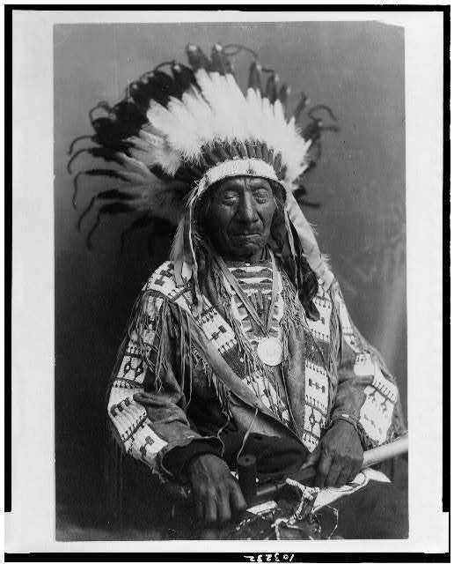

Title: [Chief Red Cloud (1822-1909.), half-length portrait, seated, facing front; holding peace pipe]   
Date Created/Published: c1915.   
 J202114 U.S. Copyright Office.  
Copyright by Joseph A. Kern, Crawford, Neb.

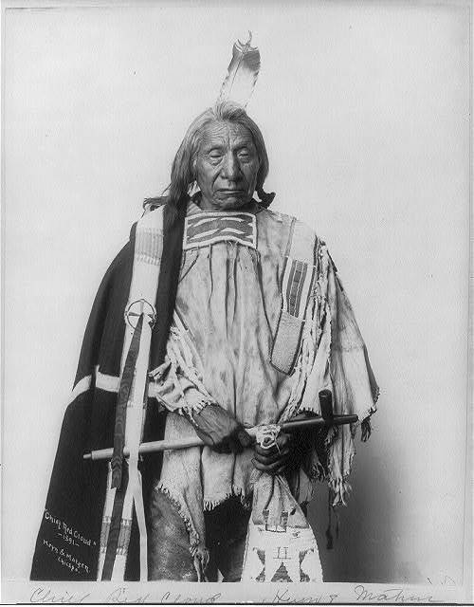

[Red Cloud, Chief, three-quarters length portrait, standing, facing slightly right, holding pipe]   
Date Created/Published: c1900.   
Notes:   
Photo copyrighted by Heyn & Matzen.

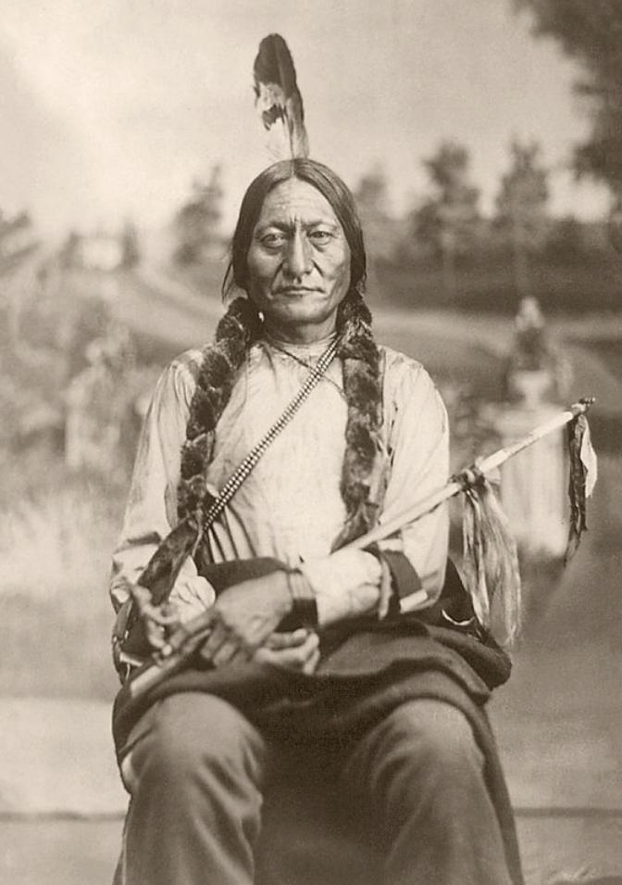

Sitting Bull was the Hunkpapa Lakota chief and holy man who defeated General Custer at the Battle of Little Bighorn on June 25, 1876. The photo shows Sitting Bull seated and holding a calumet (peace pipe). It was taken by Orlando Scott Goff about 1881.